Washington STATE Community living connections
  - Person-Centered Practice Approaches

2023

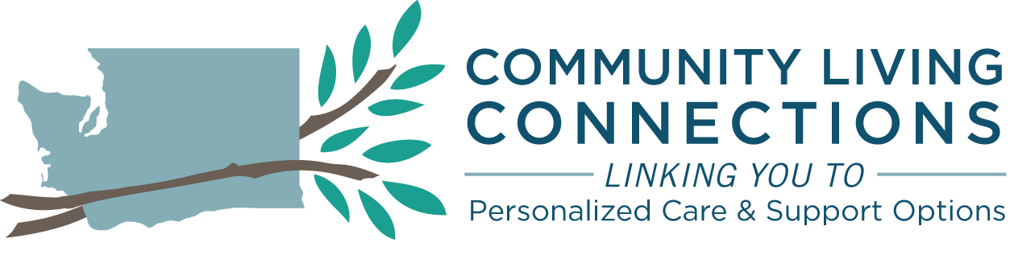

Person-Centered Practice Approaches to Aging Network service provision.
The CLC network in Washington State works diligently to provide person-centered consumer experiences and access to a full range of community-based long-term service and support options available in local communities statewide. The goal is to provide a warm hand off experience for each consumer, and collaborate with that consumer, to connect with the right service, at the right time, with the right expertise for the older adult, individual with a disability and/or the unpaid caregiver or anyone with a touch on the individual seeking support no matter which organization’s door that consumer first approaches in their local community. Washington State values the personalized experience of each consumer seeking support and works tirelessly to continually evolve the CLCs network to get consumers to right service with the right expertise at the right time.

Options Counseling

Introduction
Based on staff resources, the Area Agency on Aging (AAA) may choose whether or not to provide Options Counseling services to the target population group listed below. Options Counseling is an interactive process where individuals receive guidance in their deliberations to make informed choices about local community resources and how to access those resources. The process is directed by the consumer and may include others that the consumer chooses or those that are legally authorized to represent the consumer. Options Counseling functions include a personal interview, a decision support process, action planning, and quality assurance and follow up.

Target Population
Available, based on staff resources, to all individuals with a disability, older adults, caregivers, individuals in the person’s community and/or legal representatives who request or require for a current need and/or future planning for persons of all incomes and asset levels. Priority will be given to those who are most likely to financially impoverish themselves and become eligible for Medicaid. Included in this priority, are those individuals trying to refrain from Medicaid LTSS as they seek education, training and/or employment.

Options Counseling Functions
Personal Interview

The personal interview is an engagement with the individual through a person-centered conversation to learn about the individual’s values, strengths, preferences, and concerns. This discussion is a process of discovering factors that are important to and important for the individual in exploring local community resource options and developing an action plan. The individual may choose to have a representative from the individual’s community, and/or legal representative with them during the interview. This conversation may occur once or over a series of interactions. This personal interview should be offered within two (2) working days of the individual being identified as an Options Counseling participant.

Every attempt should be made to provide the personal interview in the setting that the individual chooses. Options Counseling may be provided in person, by phone, or by other electronic method. Whenever possible an in-person meeting with the individual is preferred. Documentation of the personal interview and all progress notes shall be maintained by the provider in accordance with the DSHS record retention schedule and the recording of service provision shall be provided in the Client Management System in accordance with reporting as required by federal funder and directives provided in Management Bulletins.

Decision Support Process

The decision support process includes the exploration of resources providing individuals with choice regarding what is right for them to assist with current and future long-term services and supports (LTSS). In addition to discussing and sharing information about available resources, the decision support process provides unbiased assistance to the person in evaluating various pathways, including the pros/cons of specific local community options (publicly and privately funded LTSS).

Providers providing decision support for Options Counseling shall have policies and procedures in place to remain free of conflicts of interest. Documentation of the decision support process and all progress notes shall be maintained by the provider in accordance with the DSHS record retention schedule and the recording of service provision shall be provided in the Client Management System in accordance with reporting as required by federal funder and directives provided in Management Bulletins.

Action Planning

The plan outlines goals, essential tasks, action steps, timelines, responsible parties and plan for follow up. The plan is directed and developed by the individual with the support of the Options Counseling staff. A copy of the actions plan will be part of the documentation for Options Counseling staff and can be given to the individual for their use and to share with others who may support the plan. Documentation of action planning and all progress notes shall be maintained by the provider in accordance with the DSHS record retention schedule and the recording of service provision shall be provided in the Client Management System in accordance with reporting as required by federal funder and directives provided in Management Bulletins. A signature line for the individual and the Options Counselor shall be made available on the plan and may serve to reinforce commitment to the process (the signature is not required). The action plan is driven by the individual for the individual.

Quality Assurance and Follow Up

Options Counseling staff should offer a follow-up appointment with the participant within ten (10) days of construction of action plan. The follow up appointment provides Options Counseling staff the opportunity to learn from the participant, what progress towards goals and steps in the action plan have occurred. The follow up appointment/s also provide Options Counseling staff a quality assurance check in to identify any barriers to implementing the action plan and the opportunity to strategize changes as needed to the action plan. Documentation of quality assurance and follow up and all progress notes shall be maintained by the provider in accordance with the DSHS record retention schedule and the recording of service provision shall be provided in the Client Management System in accordance with reporting as required by federal funder and directives provided in Management Bulletins.

Tools for Quality Assurance are attached and are optional resources for Options Counseling providers.

Aging Network Case Management

Introduction
Based on staff resources, the Area Agency on Aging (AAA) may choose whether or not to provide Aging Network Case Management services to the target population group listed below. Additional criteria may be imposed to further limit the number of persons in this target population. These criteria must be in writing. When the AAA contracts for Aging Network Case Management, the criteria shall be approved by the AAA. When the AAA directly provides case management, the AAA will have policy describing the criteria of the target population for service provision.

Aging Network Case Management is a short-term service provided to assist older adults at risk of institutionalization to explore local community resource options. This Aging Network Case Management service assists the older adult, after considering the resource options, to then engage with those local community resources that are specifically identified by the older adult. The overarching goal of Aging Network Case Management is to maintain the highest level of independence in the least restrictive setting while supporting the choice of the older adult.
Aging Network Case Management activities are person-centered, with the consumer involved in all phases, whether in an active or consultative mode. Case management functions include assessment, service plan development and implementation, and service termination planning.

Target Population
Adults aged sixty (60) or over who reside in the community in a non-residential setting and:

- Require multiple services and/or related activities performed on their behalf; AND

- Are unable to obtain the required services and/or perform the required activities for themselves; AND

- Do not have family or friends who are able and willing to provide adequate assistance.

- Meet the above criteria and require on going case management after an Adult Protective Service Investigation (APS) has been completed.

Aging Network Case Management Functions
Assessment

The assessment used for Aging Network Case Management shall identify the following:

- Identify the consumer’s needs, abilities, resources, and level of care requirements; and

- Identify current and potential care contribution by formal or informal supports available to the consumer; and

- Provide a person-centered presentation of local community resources addressing the needs of the consumer.

Once the consumer is identified as participating in Aging Network Case Management, an assessment shall be initiated within five (5) working days. If response time is over five working days, the reason for the delay must be documented. The assessment shall be performed in person as able. Collateral contacts may be made in writing, through virtual technology, over the telephone or in person. Documentation of the assessment and all progress notes shall be maintained by the provider in accordance with the DSHS record retention schedule and the recording of service provision shall be provided in the Client Management System in accordance with reporting as required by federal funder and directives provided in Management Bulletins.

Service Plan
The purpose of service plan development is to prepare a written service plan clearly identifying implementation responsibilities. The consumer shall always be involved in the service plan development. The following components shall be, at a minimum, be part of the service plan documentation. Documentation of the service plan and all progress notes shall be maintained by the provider in accordance with the DSHS record retention schedule and the recording of service provision shall be provided in the Client Management System in accordance with reporting as required by federal funder and directives provided in Management Bulletins.
- List the service options discussed with the client or his/her representative and recommend the most appropriate service plan.

- Indicate the resource preferences of the consumer.

- List formal and informal services which are already in place and will continue as part of the service plan (home health, home-delivered meals, etc.).

- Consumer signature documenting agreement with the care plan.

Service Termination Planning
Aging Network Case Management services are to provide appropriate services only for the duration needed. Once the consumer’s service plan has been collaboratively worked on, plans for termination of the Aging Network Case Management services should be considered as appropriate and documented. Documentation of service termination planning and implementation shall be maintained by the provider in accordance with the DSHS record retention schedule and the recording of service provision shall be provided in the Client Management System in accordance with reporting as required by federal funder and directives provided in Management Bulletins.

