Seattle-King County Advisory Council on Aging & Disability Services
Advocating for local, state, and national programs that promote quality of life for older people and adults with disabilities

Mailing address: PO Box 34215, Seattle, WA 98124-4215  Office address: Seattle Municipal Tower, 700 5th Ave, 51st Fl  E-mail: aginginfo@seattle.gov | Tel: 206-684-0660  Fax: 206-684-0689  Relay: 711

Application

Name: ____________________________________________________________________________________

Home address: ____________________________________________________ Zip: ____________________

Work address: ____________________________________________________ Zip: ____________________

Day phone: _____________________________________ Fax: ______________________________________

E-mail: ____________________________________________________________________________________

Send mail to: My home address My work address My fax E-mail

It is a goal to have ADS Advisory Council composition reflect the profile of the population served by Aging and Disability Services. Please provide ethnicity and age information below.

Race/ethnic background: African American/Black Hispanic/Latinx
Asian/Pacific Islander Native American
White/Caucasian Other—specify:
_____________________

Age: 18–25 45–54 65–74 85+
25–44 55–64 75–84

Membership in other organizations, boards, and councils:
1 |  | 4
2 |  | 5
3 |  | 6

In association with the Area Agency on Aging for Seattle-King County

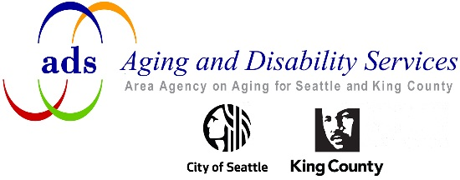

Qualifications
Please submit a resume and cover letter that summarize your qualifications and the reasons why you wish to be appointed to the ADS Advisory Council. Include any information about your experience working with older people and/or people with disabilities.

Accommodations:
Do you require any accommodation in order to participate in Advisory Council meetings?
If so, please describe:

References:
Please provide names and contact information for three (3) people who are familiar with your interests and experience.
Name |  | Relationship | Day Phone
1
2
3

Signature _______________________________________________________________ Date _____________________
If submitting electronically, type your name in the signature line above.

To submit by mail:  - If you completed the form on your computer, save it to your hard drive. The form does not save automatically.  - Print your application, resume, and cover letter.  - Mail your application package to:  ADS Advisory Council  Aging and Disability Services  PO Box 34215  Seattle, WA 98124-4215 | To submit by e-mail:  - If you completed the form on your computer, save it to your hard drive. The form does not save automatically.  - Scan documents if necessary.  - Attach your application, resume, and cover letter to an e-mail message addressed to:  aginginfo@seattle.gov

